SLIDING WORDS: WILL SLID LIKE RLSGL

**SLIDER 1: Welcome to IRIHANO Limited**

We help people to apply E-Governments services, irembo Services Primarily, E-Building permit, Revenues Declaration from RRA, Company and Enterprise Registration to RDB

## SLIDER 2: IRIHANO ONLINE [Agent]

Choose get services at IRIHANO, we are partnering with strong digital services providers in Rwanda like Bank of Kigali, Mobicash, Rwanda Telecenter Network, MTN Rwanda in order to satisfy needs of the clients of institutions we are working on behalf.

**IRIHANO ONLINE[Client]**

IRIHANO LIMITED Became online services solution, its success came from customers like Banks, Schools, Businessmen, and person

SLIDER 3.

**IRIHANO LIMITED**

## Agent

## Approach Person by person

**IRIHANO is a Private Technology company provides digital services working as agent .**

© 2021Copyright **IRIHANO LIMITED |** Digital services partner **a**

**ALL THIS SERVICES WILL COME IN PRICING TABLE (ONLINE SERVICES)**

**These are digital services can get at irihano ,**

**this**

### iREMBO AGENT SERVICES

1. Family/Local Government
2. Identification(NIDA)
3. Immigration and Emigration
4. Notarization and gazette services
5. Land Services
6. Criminal record
7. health
8. Governance
9. Education
10. Transport
11. Media
12. Tourism
13. Police
14. Online system
15. Full access
16. Free apps
17. Multiple slider
18. Free domin
19. Support unlimited
20. Payment online
21. Cash back

### BANK OF KIGALI AGENT SERVICES

1. Pay irembo services
2. CASH Deposit
3. Send money
4. Multiple s
5. Pay Bill (Airtime, Canal+, Cash power)
6. CASH Collection (Ex: WASAC Payment)
7. CASH WITHDRAW

### MOBICASH AGENT SERVICES

1. PAY IREMBO SERVICES
2. PAY RRA TAXES
3. PAY Electricity Bill
4. CANAL+ of StarTimes
5. Register investor or CHILD to RNIT (Rwanda National Investment Trust)/ Iterambere Fund
6. Register member or Pay (LTSS) to EJO HEZA
7. Pay mituweli to RSSB
8. Pay RSSB

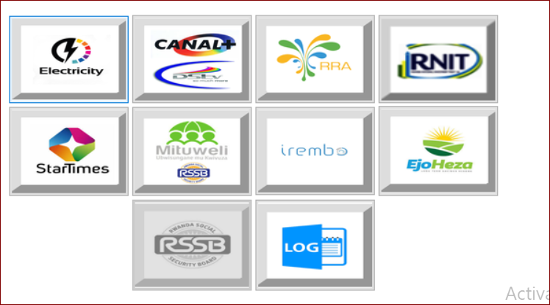

IRIHANO

### RRA Declaration SERVICES

1. Domestic taxes declaration (:
2. Company Declaration)
3. Moto vehicle taxes Declaration
4. Moto vehicle Transfer declaration
5. District Revenues taxes Declaration: Trading license, Land taxes, Public cleaning fees, Market fees declaration) and others services
6. Tax Clearance Declaration
7. Searching TIN by NID
8. We help people to send the closing a company request to RRA

IRIHANO

### OTHER ONLINE SERVICES

1. Company registration and De-Registration to RDB
2. Enterprise Registration to RDB
3. E-Building Permit (**GUSANA INYUBAKO BIHINDURA IMITERERE YAYO** , **GUSANA INYUBAKO BIDAHINDURA IMITERERE YAYO,** GUSANA NO KUBAKA URUGO)
4. Sending Email via Internet
5. Opening Email
6. IECMS Services (KOHEREZA IKIREGO MU RUKIKO)
7. FDI services

**OTHER SERVICES**

**1.DESIGN: -Web Design:** Web Design &Maintenance

**-GRAPHIC DESIGN:, Business cards, Postcards, Invitation cards, Logo, Banner , Flyers, Stamp,**

**2.Photocopy**

**3.Print**

**4.Typing Document**

**5.Advertising**

**6.Delivery**

**7.IT Support**

8.IT Sales & Support

9.ICT Training

**Most of clients are coming to irihano to ask help of applying digital services, ervery service is paid immediately, and the system count every operation if billing number or reference is sucessfuly paid .Daily operation or monthly are reported.**

FREQUENTY QUESTIONS AND ANSWERS:

1.What is IRIHANO?,IRIHANO is Rwanda private Technology company

2.Why choose IRIHANO? In our company we help you to apply and pay digital services .Also with us you can get other technology services.

3.Can I Advertise my Shop on IRIHANO website ?, Yes welcome visit shop page upload your article , webmaster will verifier the uploaded article before of being published. On this page you will see number of reviewed, description provided ,contact of supplier ( after a clients will calling you or chatting you how they can get your goods).

4.

-----------------------------------------IBINDI NI EJO SOIR--------------------------------